**Encryption and Decryption By RSA Algorithm**

# Input

* **For encryption**

IMAGE , Prime numbers P and Q , Value of E

* **For decryption**

Converted Text file, d and n

# Process

1. Choose p and q which are prime numbers and need to be taken from user , to make RSA more secure choose distinct prime numbers
2. Product of p and q is denoted by n
3. Now we need to find EULAR PHI FUCTION of n by formula

φ(n) = (p - 1) * (q - 1)

1. Now choose another prime number e which has the GCD as 1 and is less than n. e should be a coprime number.
2. Find the value of D by formula

(d * e) % φ(n) = 1 or D =p [p*e] % p(n)=1

1. Public key is (e, n)
2. Private key is (d, n)

So formula for ENCRYPTION is

C= me % n

So formula for DECRYPTION is

m= cp % n

# Output

* **For encryption**

Converted file in text format

* **For decryption**

Image returned

**Work Flow**

* **For Encryption**

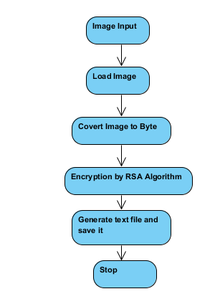

* **For Decryption**

